Event Driven Pipeline
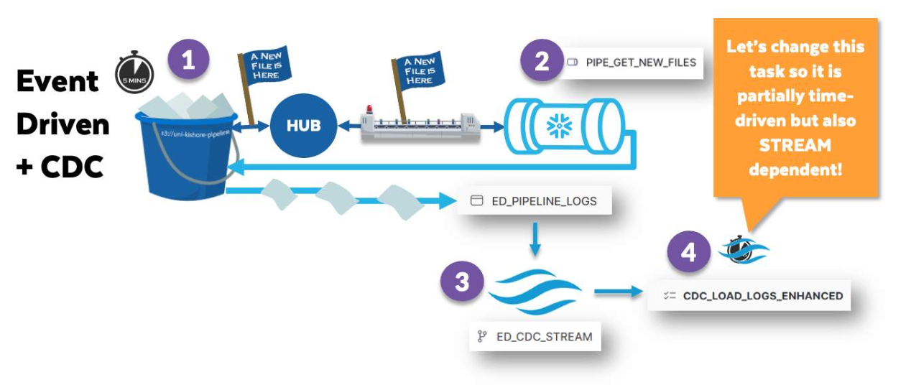
Confirming Data is Flowing
The data makes two stops in your account. The first table the data lands in is ED_PIPELINE_LOGS.
The data arrives there because of the Snowpipe named GET_NEW_FILES.
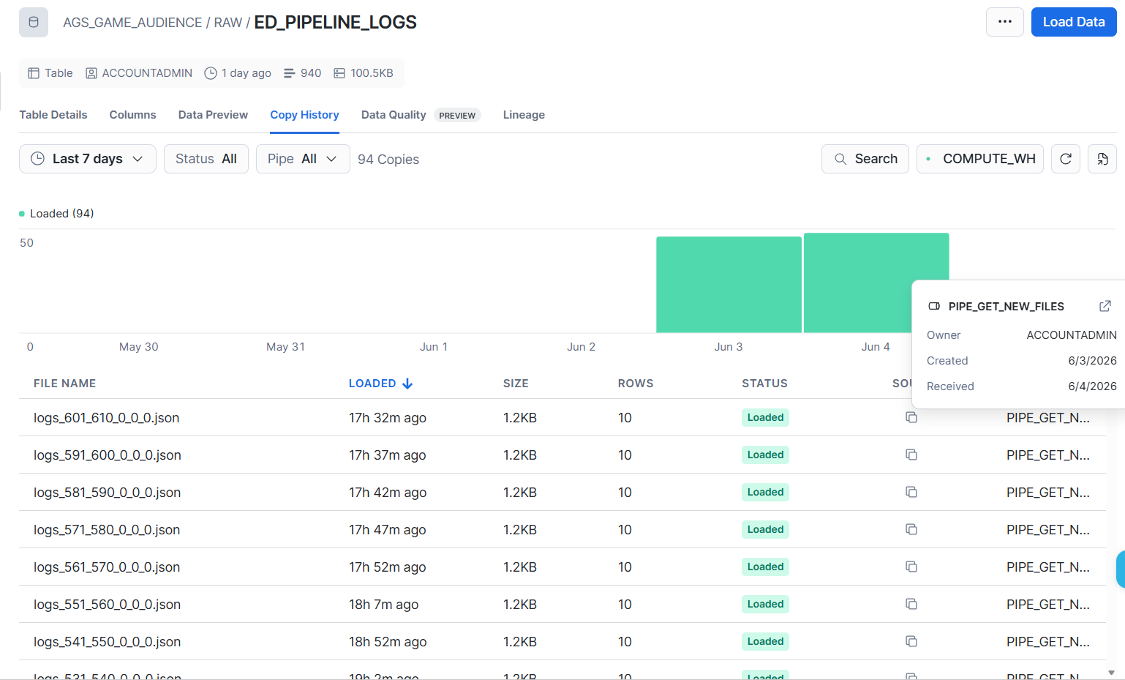
The second stop for the data is the AGS_GAME_AUDIENCE.ENHANCED.LOGS_ENHANCED table.
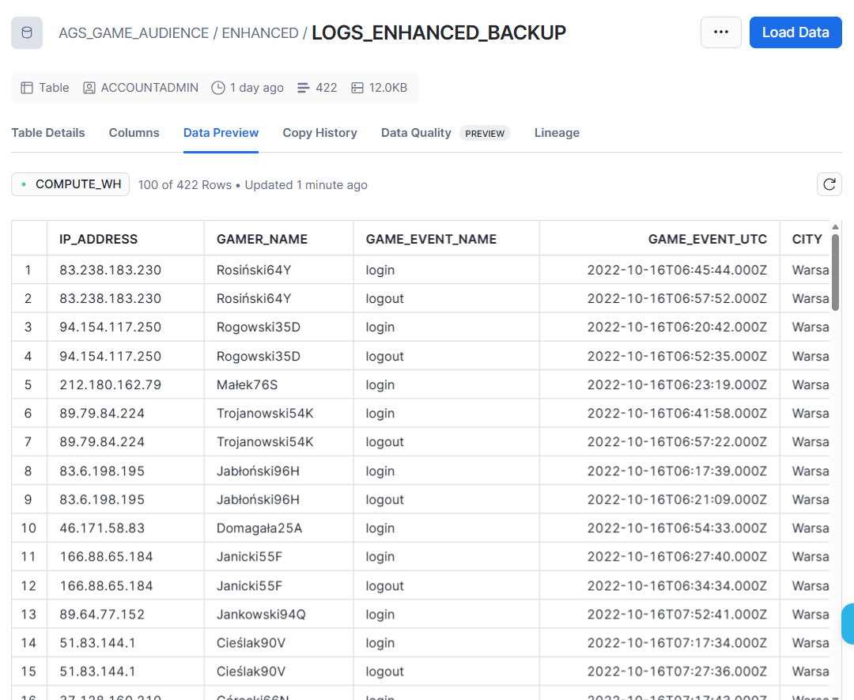

Below is the pipeline from raw data to logs enhanced table
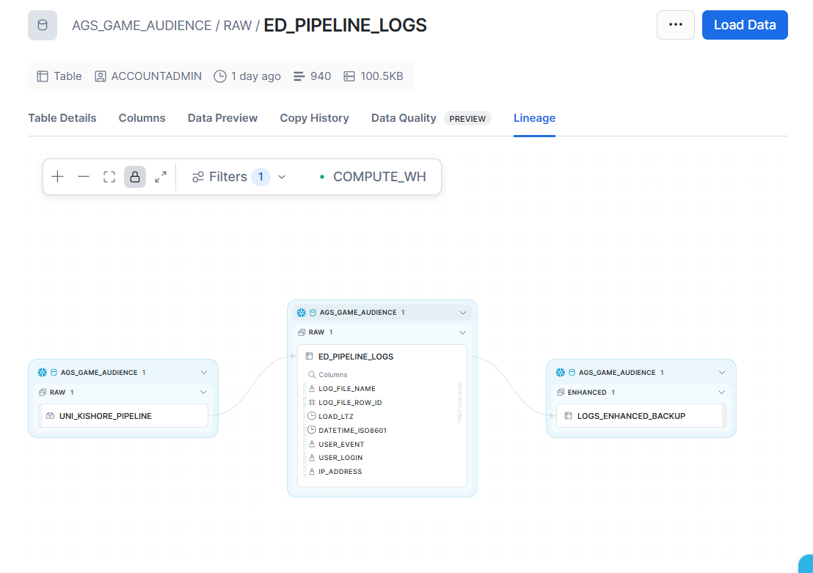
Add A Stream Dependency to the Task Schedule
